ESSAY WRITING

Essays have a variety of structures. Below is one way that an essay can be structured:

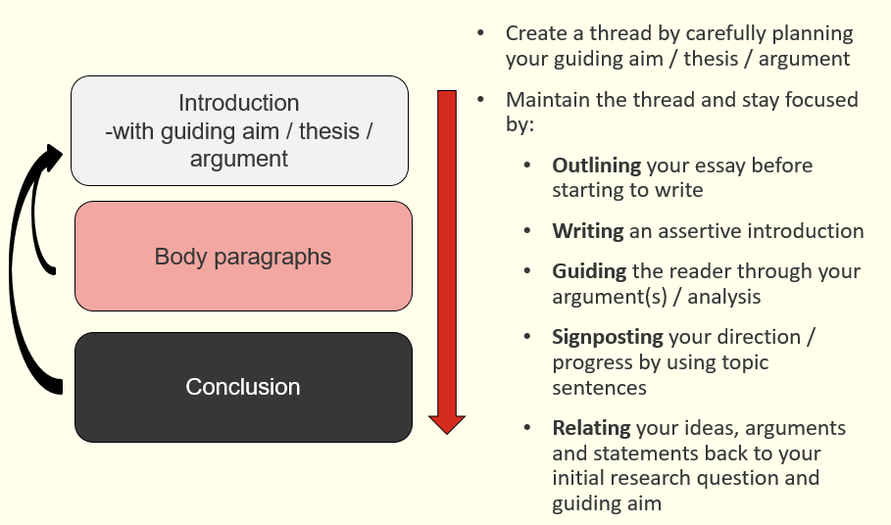

Introductions can also have many different functions, such as:

- Introduce the topic generally
- Narrow the topic and highlight the niche in which you are writing
- Indicate why & in what ways the topic is important
- Highlight any differences of opinion about the topic
- Identify key definitions
- Clearly state the writer's guiding aim [i.e. the writer’s forthcoming argument]
- Describe how the assignment will be structured

Look at the following introductions. Which of the above functions can you find?

Example 1:
International secondments are potentially a valuable tool in today’s global economy, but the costs associated with sending an individual abroad can be very high (e.g. Black and Gregersen, 1991). This essay aims to evaluate whether and to what extent organisations can gain a return on their investment when sending an employee on secondment. In particular it focuses on the extent to which knowledge is transferred between offices during a secondment, as well as assessing repatriate motivation and retention after a secondment, in order to assess to what extent the competitive advantage gained justifies the outlay.
The essay will begin with a critical evaluation of the literature on the topic of secondments and repatriation. It aims to outline the development of academic theory and research that has been undertaken, in order to provide a suitable context for the evaluation of secondments. The review will start with an overview of the purpose of secondments and the costs of sending an individual on an international assignment, compared with the return on investment. It will then focus on the specific issues of the types of knowledge gained while on secondment, how organisations can capture and share this information, and the barriers to knowledge transfer, including repatriate motivation and career development.

Example 2:
In February 1995, Barings Bank, the oldest Merchant Bank in London, went under with losses in excess of $1 billion. The scandal rocked the international banking world and a 28-year old trader, Nick Leeson, whose derivative trading activities were blamed for the disaster, is now serving a six-and-a-half year jail sentence in Singapore. In this paper I would like to look at the circumstances of this well-known case, and the implications for wider financial markets. In particular I would like to address the question, are our financial markets too deregulated?

Planning your next steps:

Where am I now in my writing process? What have I done? | Where do I want to be? | How will I get there?

